Basic Electronics
UNIT - 1
Voltage:
Voltage is the movement of electric charges It can be thought of as the force that pushes the charges. Voltage can cause charges to move, and since moving charges is a current, voltage can cause a current.
Resistors:
A resistor is a passive two-terminal electrical component that implements electrical resistance as a circuit element. In electronic circuits, resistors are used to reduce current flow, adjust signal levels,
Fixed and Variable resistors
- Fixed resistors: Fixed resistors are by far the most widely used type of resistor. They are used in electronics circuits to set the right conditions in a circuit. Their values are determined during the design phase of the circuit, and they should never need to be changed to "adjust" the circuit. There are many different types of resistor which can be used in different circumstances and these different types of resistor are described in further detail below.
- Variable resistors: These resistors consist of a fixed resistor element and a slider which taps onto the main resistor element. This gives three connections to the component: two connected to the fixed element, and the third is the slider. In this way the component acts as a variable potential divider if all three connections are used. It is possible to connect to the slider and one end to provide a resistor with variable resistance.
Color coding resistors
Components and wires are coded with colors to identify their value and function.
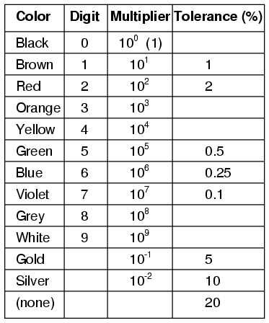

The colors brown, red, green, blue, and violet are used as tolerance codes on 5-band resistors only. All 5-band resistors use a colored tolerance band. The blank (20%) “band” is only used with the “4-band” code (3 colored bands + a blank “band”).
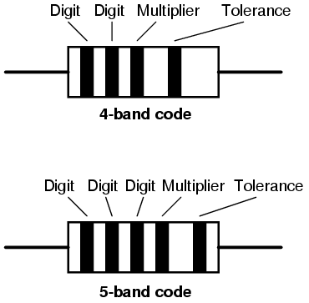

Example #1: A resistor colored Yellow-Violet-Orange-Gold would be 47 kΩ with a tolerance of +/- 5%.

Resistors in series and parallel:
In a series circuit, the output current of the first resistor flows into the input of the second resistor; therefore, the current is the same in each resistor. In a parallel circuit, all of the resistor leads on one side of the resistors are connected together and all the leads on the other side are connected together.
Inductors: An inductor, also called a coil, choke, or reactor, is a passive two-terminal electrical component that stores energy in a magnetic field when electric current flows through it. An inductor typically consists of an insulated wire wound into a coil around a core.
Fixed and Variable inductors:
Fixed inductor: An inductor whose coils are wound in such a manner that the turns remain fixed in position with respect to each other, and which either has no magnetic core or has a core whose air gap and position within the coil are fixed.
Variable Inductor: An inductor or reactor whose inductance is continuously adjustable.

Inductance
It is the current production in a coil due to change in magnetic flux in itself or new coil. Whenever there is a coil, and you have a change in magnetic flux or change in magnetic field, an induced emf* is generated in that coil or wire. This very property is inductance.
*(Electromotive force (emf) is a measurement of the energy that causes current to flow through a circuit. It can also be defined as the potential difference in charge between two points in a circuit. Electromotive force is also known as voltage, and it is measured in volts.)

Self Inductance
Self-induction means the coils induce the emf themselves. There is a change in the magnetic flux through that coil and because of this, the current will be induced in the coil by itself. So once the current get induced, the current tries to oppose the flux.

Mutual Inductance
Here, there are two coils placed near each other. The first coil will make turns and carry the current which results in the magnetic field. As both the coils nearly close to each other, the magnetic field through one coil will all pass through the other coil. So one coil causes the change in magnetic flux because of which current is induced in the other coil.

Faraday’s law of electromagnetic induction Capacitors:

Faraday's law of induction is a basic law of electromagnetism predicting how a magnetic field will interact with an electric circuit to produce an electromotive force (EMF). It is the fundamental operating principle of transformers, inductors, and many types of electrical motors, generators and solenoids.
The Maxwell–Faraday equation describes the fact that a spatially varying electric field always accompanies a time-varying magnetic field, while Faraday's law states that there is EMF on the conductive loop when the magnetic flux through the surface enclosed by the loop varies in time.
Faraday's law had been discovered and one aspect of it was formulated as the Maxwell–Faraday equation later. The equation of Faraday's law can be derived by the Maxwell–Faraday equation (describing transformer EMF) and the Lorentz force (describing motional EMF). The integral form of the Maxwell–Faraday equation describes only the transformer EMF, while the equation of Faraday's law describes both the transformer EMF and the motional EMF.

Lenz’s law of electromagnetic induction Capacitors:

Lenz's law, named after the physicist Emil Lenz who formulated it in 1834, states that the direction of the current induced in a conductor by a changing magnetic field is such that the magnetic field created by the induced current opposes the initial changing magnetic field.
Lenz's law states that the current induced in a circuit due to a change or a motion in a magnetic field is so directed as to oppose the change in flux and to exert a mechanical force opposing the motion.
Capacitor
It is a device used to store charge in an electrical circuit
Principles of capacitance
A capacitor works on the principle that the capacitance of a conductor increase appreciably when an earthed conductor is brought near it. Thus a capacitor has two plates separated by a distance having equal and opposite charges.

Parallel Plate capacitor: Take an insulated metal plate A. Charge the plate to its maximum potential. Now take another insulated plate B. Take the plate B nearer to plate A. You will observe that negative charge will be produce on the plate near to plate A and the same amount of positive charge will be produced on the other side of plate B.
Now the plate B will start affecting the plate A slowly. The negative charge will start decreasing the electric potential of plate A. But positive charge helps in increasing the potential. But the effect of negative charge is much more than that of the positive because the negative side of plate is near to the plate A. So potential of A will start decreasing and it can be charged again to raise its potential to maximum.

.

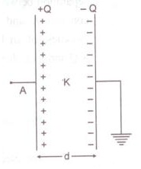

The result is that the charge carrying capacity of a conductor can be increased by bringing an uncharged conductor in its nearby area.
Permittivity
In electromagnetism, the absolute permittivity, often simply called permittivity and denoted by the Greek letter ε (epsilon), is a measure of the electric polarizability of a dielectric. A material with high permittivity polarizes more in response to an applied electric field than a material with low permittivity, thereby storing more energy in the electric field. In electrostatics, the permittivity plays an important role in determining the capacitance of a capacitor.

Dielectric

A dielectric is an electrical insulator that can be polarized by an applied electric field. When a dielectric material is placed in an electric field, electric charges do not flow through the material as they do in an electrical conductor but only slightly shift from their average equilibrium positions causing dielectric polarization.

Definition of Dielectric Constant

The dielectric constant is the ratio of the permittivity of a substance to the permittivity of free space. It is an expression of the extent to which a material concentrates electric flux, and is the electrical equivalent of relative magnetic permeability.
Dielectric strength:
The term dielectric strength has the following meanings:
Of an insulating material, the maximum electric field that a pure material can withstand under ideal conditions without breaking down
Energy stored in a capacitor

Air Capacitor:
Air capacitors are capacitors which use air as their dielectric. The simplest air capacitors are made of two conductive plates separated by an air gap. Air capacitors can be made in a variable or fixed capacitance form. ... Variable air capacitors are used more often because of their simple construction
Its function is to store the electrical energy and give this energy again to the circuit when necessary. In other words, it charges and discharges the electric charge stored in it. Besides this, the functions of a capacitor are as follows: It blocks the flow of DC and permits the flow of AC.
Paper Capacitor:
Paper Capacitor is a fixed capacitor in which flat thin strips of metal foil (usually aluminium) is separated by dielectric material paper. Paper capacitors are used for medium capacitance value 1nF to 1uF mainly at power line frequency.
There are various applications of the paper capacitors. Some of them are:
- This can be used in various electrical and electronic applications.
- This can be utilized in filtering applications.
- In the high voltage required applications these are used.
- In the high current requirements, these capacitors are used.

Mica Capacitor:
Mica capacitors are generally used when the design calls for stable, reliable capacitors of relatively small values. They are low-loss capacitors, which allow them to be used at high frequencies, and their value does not change much over time. Mica minerals are very stable electrically, chemically and mechanically.
Mica capacitors are used in applications which call for low capacitance values and high stability, while exhibiting low losses. Their main use is in power RF circuits where stability is of utmost importance. Silver mica capacitors are used in high frequency tuned circuits, such as filters and oscillators.
Teflon
Ceramic:
A ceramic capacitor is a fixed-value capacitor where the ceramic material acts as the dielectric. It is constructed of two or more alternating layers of ceramic and a metal layer acting as the electrodes. The composition of the ceramic material defines the electrical behavior and therefore applications.
The applications of ceramic capacitors include:
- Transmitter stations
- Induction furnaces
- High voltage laser power supplies
- Power circuit breakers
- High-density applications
- Printed circuit boards
These capacitors are also used as a general-purpose capacitor and are also used across the brushes of the DC motors in order to minimize the RF noise.

Plastic:
Plastic film capacitor is a capacitor that uses plastic film as the dielectric and aluminum or zinc as the electrodes to store electric charge
Plastic capacitors are used for high-frequency high-power applications such as induction heating, for pulsed power energy discharge applications, and as AC capacitors for electrical distribution. The AC voltage ratings of these capacitors can range up to 400 kV.

Electrolytic capacitor :
An electrolytic capacitor (occasionally abbreviated e-cap) is a polarized capacitor whose anode or positive plate is made of a metal that forms an insulating oxide layer through anodization. This oxide layer acts as the dielectric of the capacitor.
They are commonly used as filtering devices in various power supplies to reduce the voltage ripple. When used in switching power supplies, they are often the critical component limiting the usable life of the power supply, so high quality capacitors are used in this application.
Capacitors in series and parallel
When capacitors are connected in series, the total capacitance is less than any one of the series capacitors' individual capacitances. ... When capacitors are connected in parallel, the total capacitance is the sum of the individual capacitors' capacitances.
Kirchhoff’s Current Law (KCL),
Kirchhoff's Current Law (KCL) is Kirchhoff's first law that deals with the conservation of charge entering and leaving a junction. ... His current law states that for a parallel path the total current entering a circuits junction is exactly equal to the total current leaving the same junction. This is because it has no other place to go as no charge is lost.
In other words the algebraic sum of ALL the currents entering and leaving a junction must be equal to zero as: Σ I_{IN} = Σ I_{OUT}.

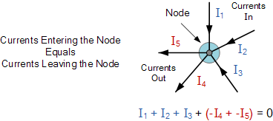

Here, the three currents entering the node, I₁, I₂, I₃ are all positive in value and the two currents leaving the node, I₄ and I₅ are negative in value. Then this means we can also rewrite the equation as;
I₁ + I₂ + I₃ – I₄ – I₅ = 0
The term Node in an electrical circuit generally refers to a connection or junction of two or more current carrying paths or elements such as cables and components. Also for current to flow either in or out of a node a closed circuit path must exist. We can use Kirchhoff’s current law when analysing parallel circuits.

Kirchhoff’s Voltage Law (KVL)

Kirchhoffs Voltage Law or KVL, states that “in any closed loop network, the total voltage around the loop is equal to the sum of all the voltage drops within the same loop” which is also equal to zero. In other words the algebraic sum of all voltages within the loop must be equal to zero. This idea by Kirchhoff is known as the Conservation of Energy.
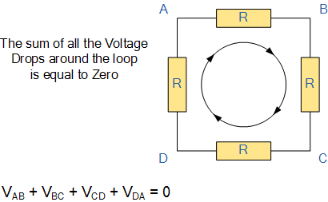

Starting at any point in the loop continue in the same direction noting the direction of all the voltage drops, either positive or negative, and returning back to the same starting point. It is important to maintain the same direction either clockwise or anti-clockwise or the final voltage sum will not be equal to zero. We can use Kirchhoff’s voltage law when analysing series circuits.

Node Analysis
Nodal analysis is a method that provides a general procedure for analyzing circuits using node voltages as the circuit variables. Nodal Analysis is also called the Node-Voltage Method.
Some Features of Nodal Analysis are as
- Nodal Analysis is based on the application of the Kirchhoff’s Current Law (KCL).
- Having ‘n’ nodes there will be ‘n-1’ simultaneous equations to solve.
- Solving ‘n-1’ equations all the nodes voltages can be obtained.
- The number of non reference nodes is equal to the number of Nodal equations that can be obtained.
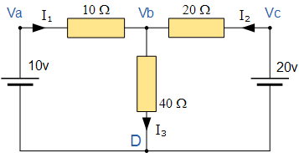

Procedure of Nodal Analysis
Follow these steps while solving any electrical network or circuit using Nodal analysis.
- Step 1 − Identify the principal nodes and choose one of them as reference node. We will treat that reference node as the Ground.
- Step 2 − Label the node voltages with respect to Ground from all the principal nodes except the reference node.
- Step 3 − Write nodal equations at all the principal nodes except the reference node. Nodal equation is obtained by applying KCL first and then Ohm’s law.
- Step 4 − Solve the nodal equations obtained in Step 3 in order to get the node voltages.
Now, we can find the current flowing through any element and the voltage across any element that is present in the given network by using node voltages.

Mesh Analysis:
Mesh analysis is a method which is used to solve planar circuits for the currents at any place in the electrical circuit. Planar circuits are circuits that can be drawn on a plane surface with no wires crossing each other. Mesh analysis and loop analysis both make use of Kirchhoff’s voltage law to arrive at a set of equations guaranteed to be solvable if the circuit has a solution.^{[1]} Mesh analysis is usually easier to use when the circuit is planar, compared to loop analysis.

RC Circuit:
An RC circuit is a circuit with both a resistor (R) and a capacitor (C). RC circuits are freqent element in electronic devices. They also play an important role in the transmission of electrical signals in nerve cells.

RL Circuit,

RLC Circuits

Sinusoidal Voltage and Current,

Definition of Instantaneous,

Peak,

Peak to Peak,

Root Mean Square and Average Values.

Voltage-Current relationship in Resistor,

Inductor and Capacitor

Passive Filters:

Low Pass,

High Pass,

Band Pass

Band

Stop.

